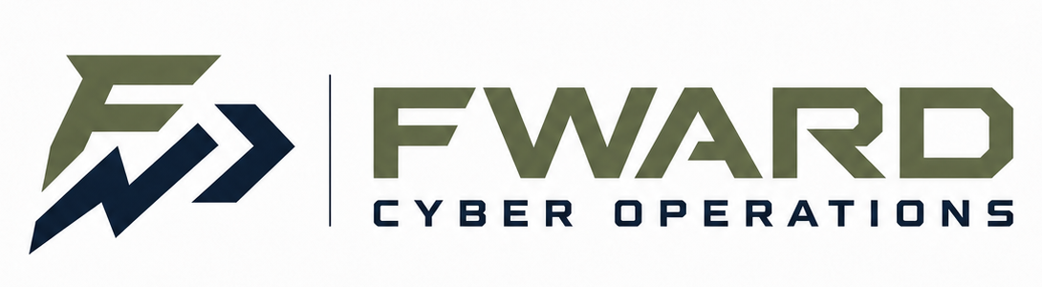
Offensive · Defensive · Industrial Control Systems · AI-Enabled Cybersecurity
Service-Disabled Veteran-Owned Small Business (SBA VetCert in process) | Sheridan, Wyoming
CAPABILITY STATEMENT Harold Fisher III, Managing Member · harold.fisher.iii@gmail.com
CORE COMPETENCIES
▪ Penetration Testing & Offensive Security — network, web application, and adversary-emulation assessments performed to industry methodologies (GPEN, GWAPT certified).
▪ Defensive Cyber Operations & Incident Response — intrusion detection and traffic analysis, incident handling, threat hunting, and defensible security architecture (GCIA, GCIH, GDSA certified).
▪ ICS / OT & Critical Infrastructure Security — assessment and defense of industrial control systems, with hands-on experience securing and training water and wastewater utilities (GICSP certified).
▪ Cybersecurity Training & Workforce Development — design and delivery of practitioner training and awareness programs, currently delivered to rural water systems across the southern United States.
▪ Security Engineering, Automation & AI — custom Python security tooling (GPYC certified), AI/LLM-enabled security workflows, and secure systems design.
▪ Governance, Strategy & Policy — security program planning, policy development, and leadership advisory (GSTRT certified).
DIFFERENTIATORS
▪ Both principals are U.S. military veterans (Army and Air Force) and active practitioners: one serving as IT & cybersecurity manager for a critical-infrastructure-focused nonprofit, the other as a cybersecurity engineer at a university.
▪ 15 GIAC certifications across two principals, spanning offensive, defensive, ICS, engineering, and leadership disciplines.
▪ 99th-percentile performers in National Cyber League competition events.
▪ Rare small-business depth in water-sector ICS/OT security — a national critical-infrastructure priority (EPA, CISA, USDA).
▪ Principals have held TS/SCI (through 2024, continuous evaluation) and Secret clearances while in service.
▪ Two-person firm: senior practitioners do the work — low overhead, direct accountability, rapid response.
PERSONNEL & CERTIFICATIONS
Harold Fisher III — Founder / Principal Consultant  GIAC (9): GWAPT, GPEN, GICSP, GCIA, GPYC, GCIH, GSEC, GISF, GFACT  B.S. Cybersecurity, SANS Technology Institute (final course in progress); A.A.S. IT & Cybersecurity, ENMU-Ruidoso. U.S. Army veteran (2024); held TS/SCI. | Stephen Washington — Founder / Principal Security Engineer  GIAC (6): GDSA, GSTRT, GPEN, GCIH, GSEC, GFACT  B.S. Computer Science. Cybersecurity engineer in higher education. U.S. Air Force veteran; held Secret clearance.
COMPANY DATA
Legal Name: FWARD Cyber Operations LLC  Location: Sheridan, WY 82801  Structure: Limited Liability Company | UEI: Pending (SAM.gov in process)  CAGE: Pending  Socioeconomic: Small Business; SDVOSB (VetCert in process) | NAICS: 541512, 541519, 541511, 541690, 611420  Accepts: EFT / Government Purchase Card  POC: harold.fisher.iii@gmail.com

